City of London Livery companies 01
A Livery Company is a type of Guild or professional association that has its origins in medieval times in the City of London. Almost all of them are styled the "Worshipful Company of" their respective craft, trade or profession. They nowadays provide charitable-giving and networking opportunities. 16 of the City of London's livery companies met in 1876 which led to the foundation of the City and Guilds of London Institute. The newest Guild was granted livery status in 2023.
Below, there are 20 Livery Company Coats of Arms. To help you, there is also listed the names of the Worship Company coats of arms represented. Match them up.
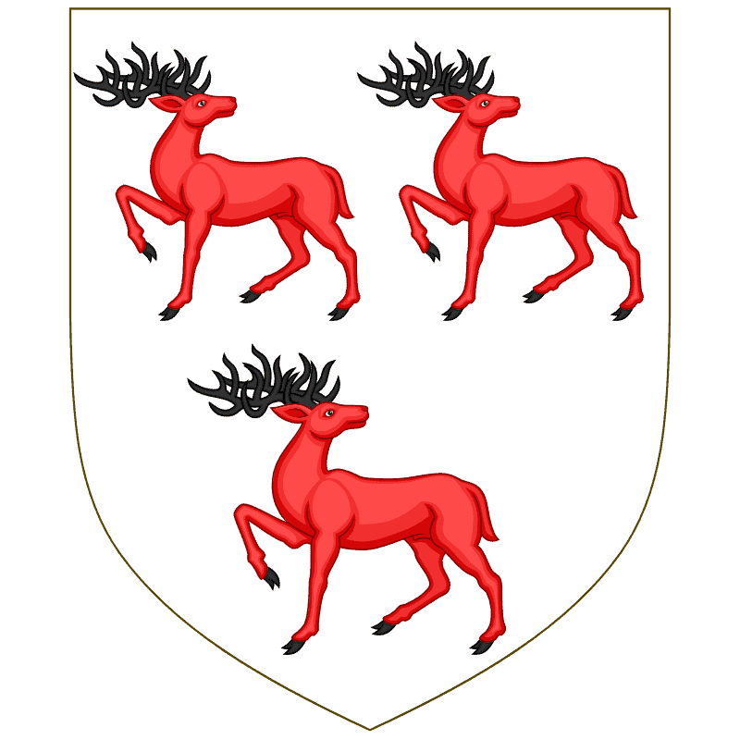 | 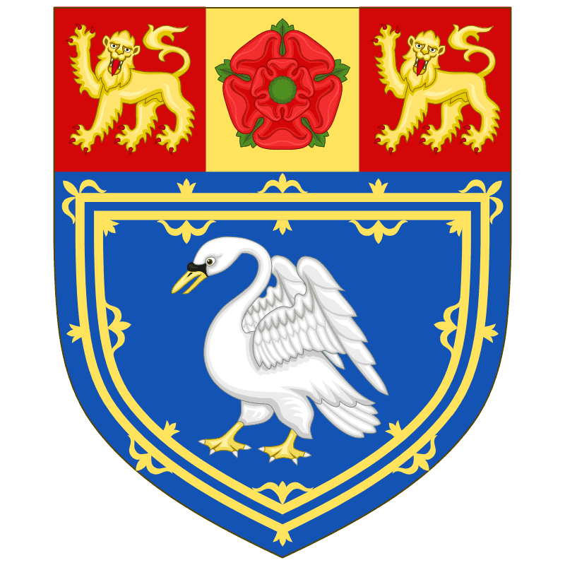 | 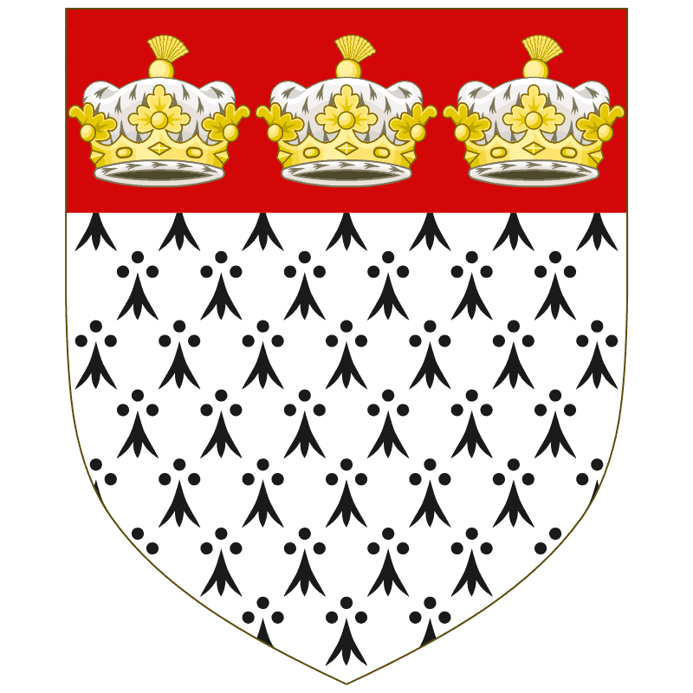 |  | 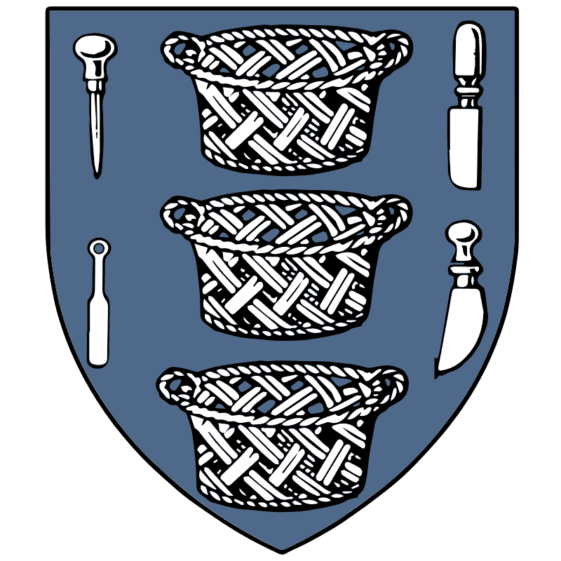
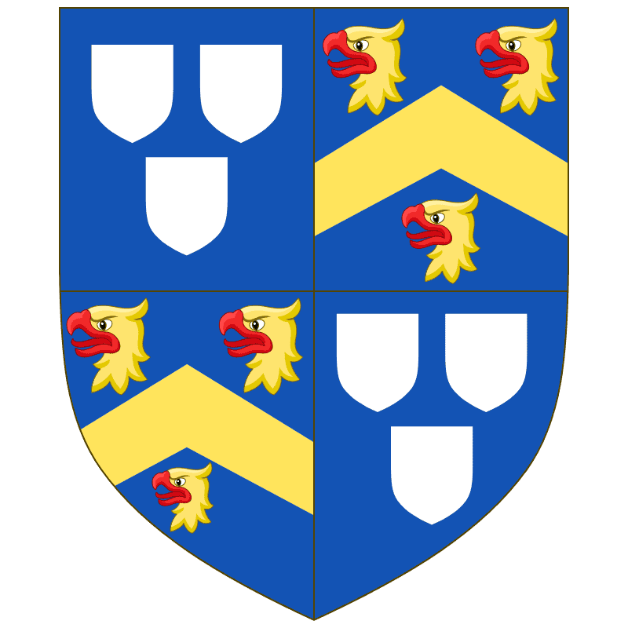 | 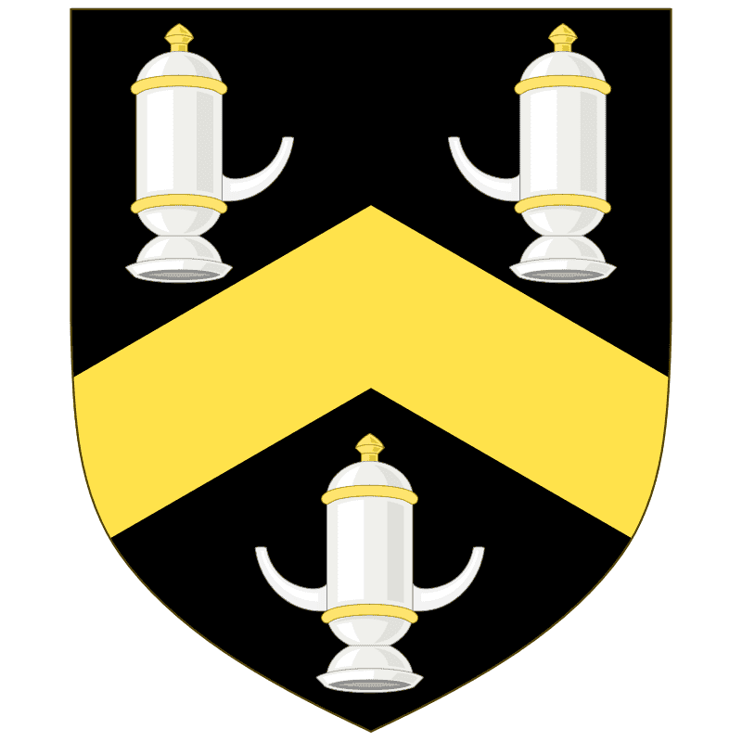 |  | 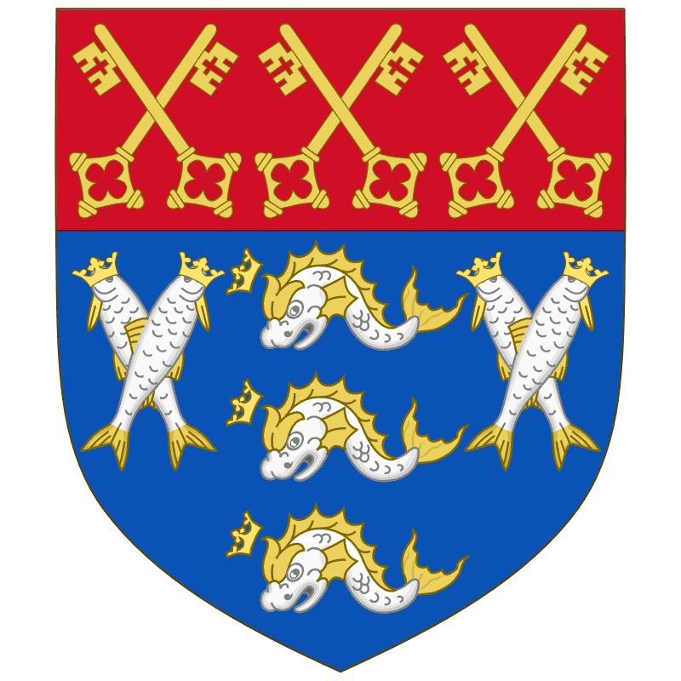 | 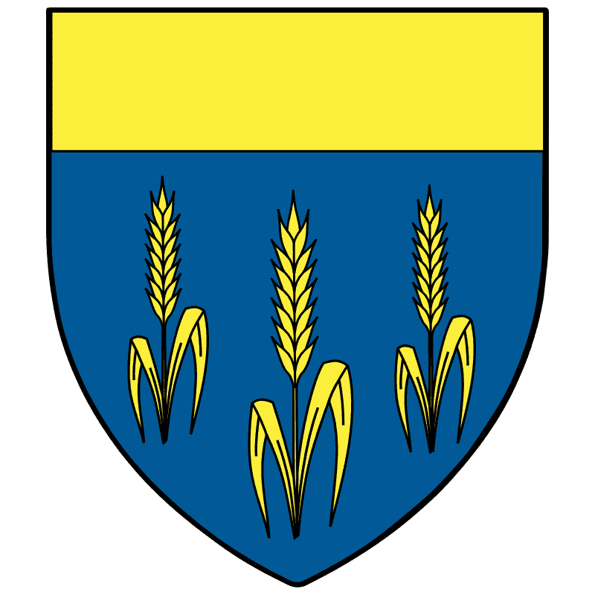
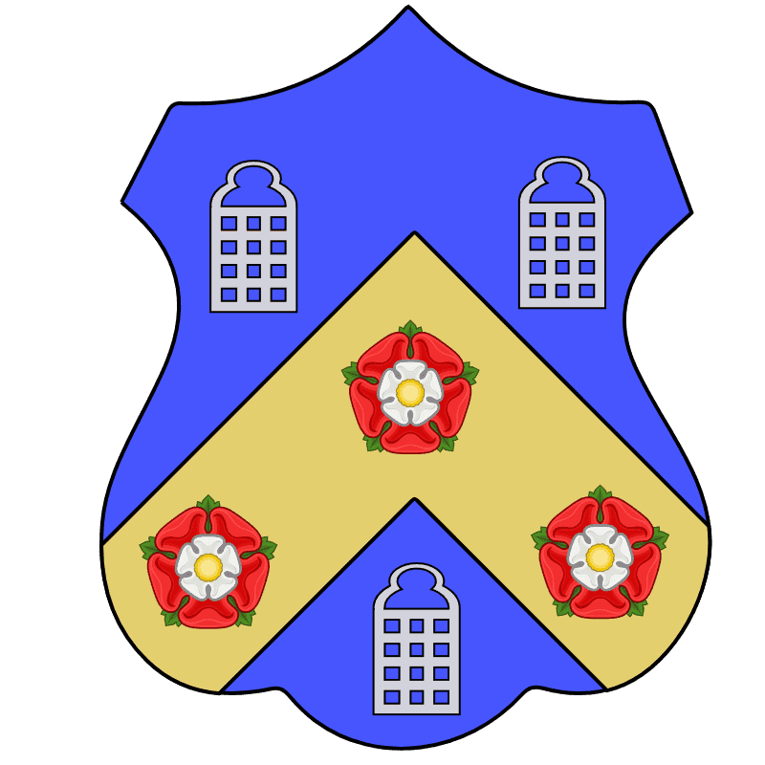 | 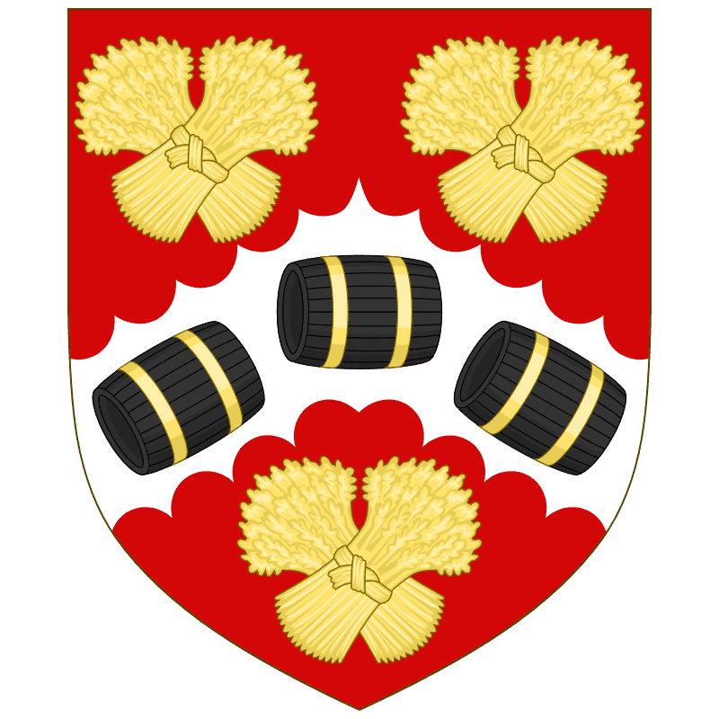 | 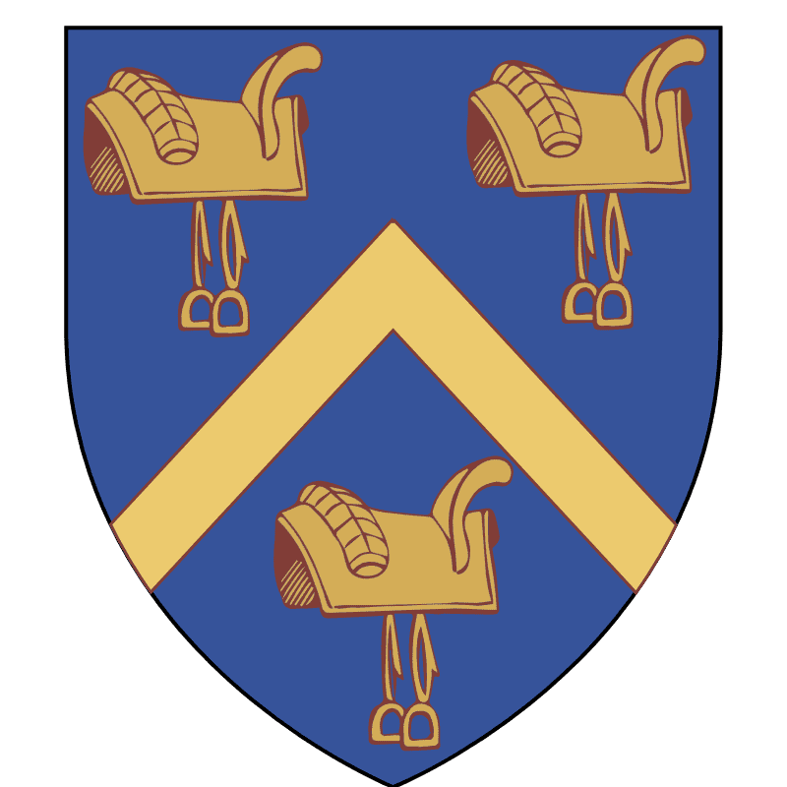 | 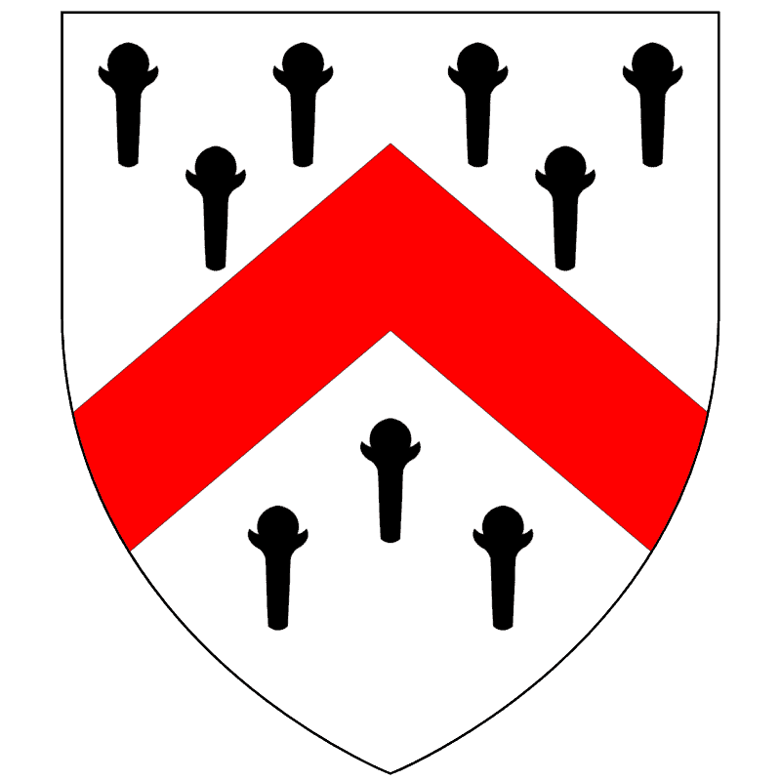 | 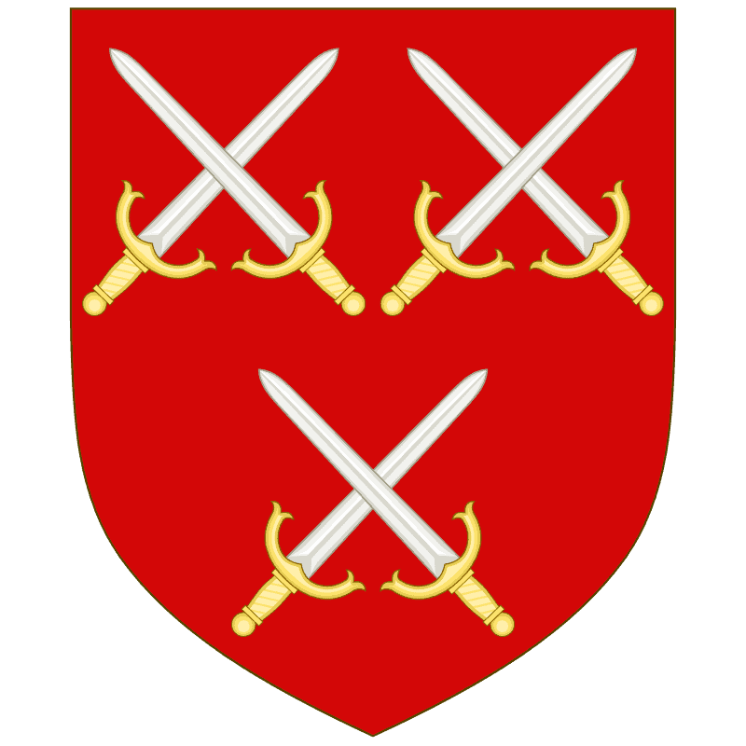
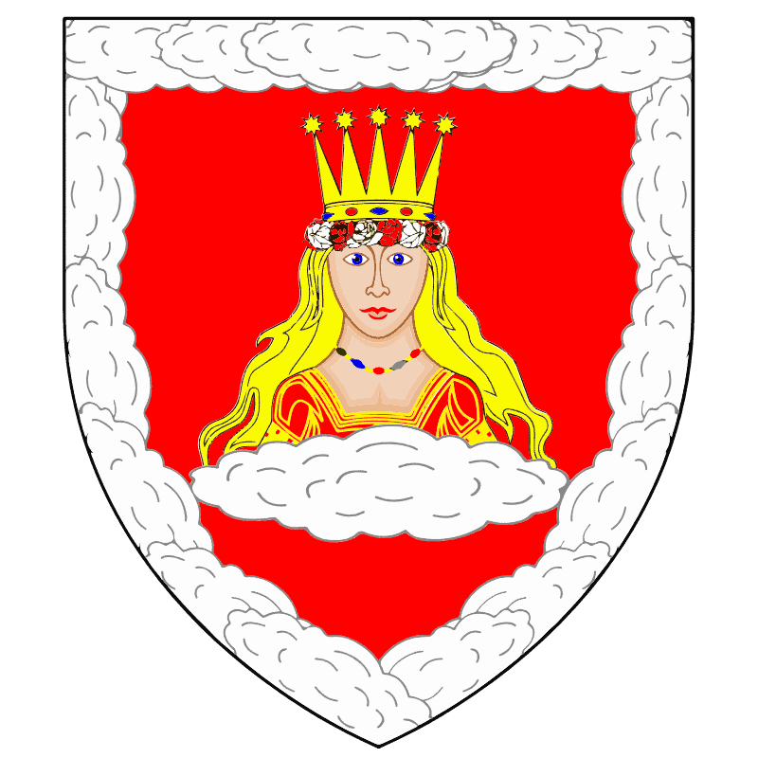 | 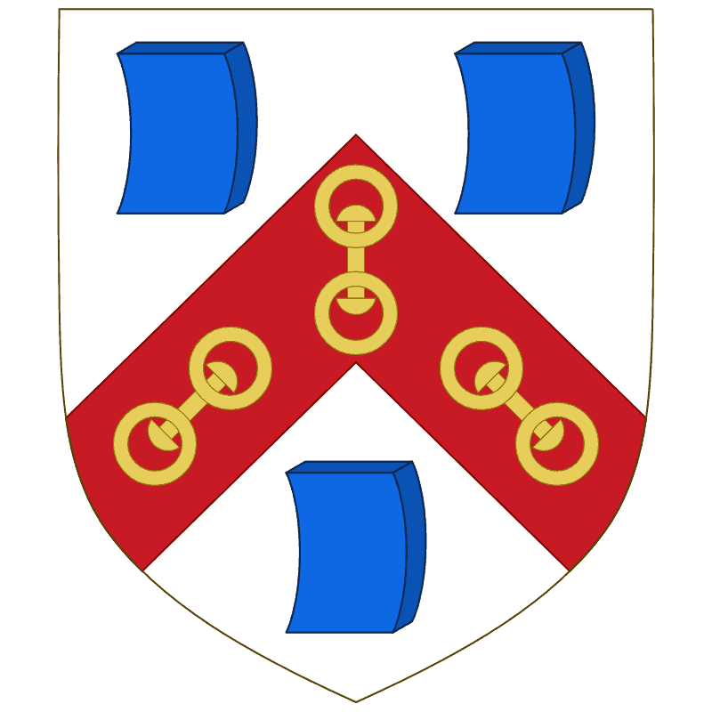 | 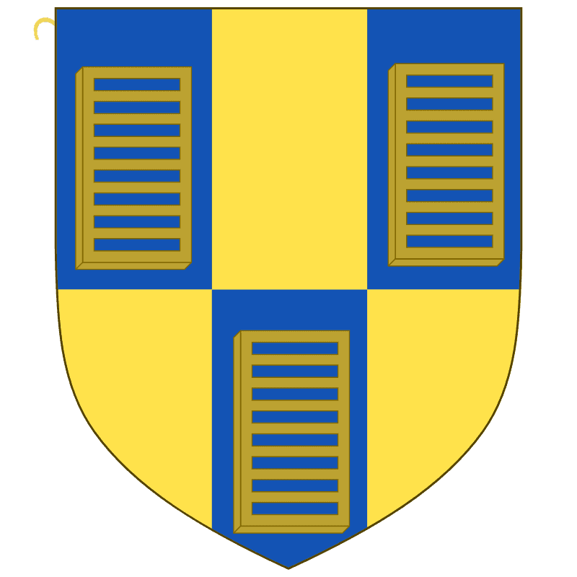 | 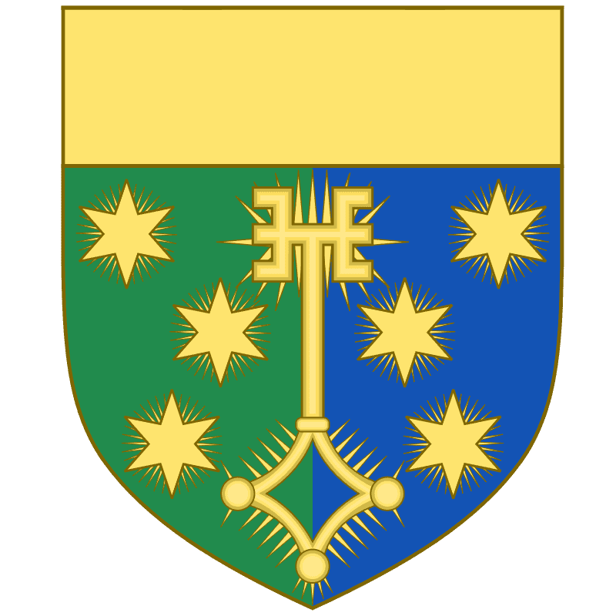 | 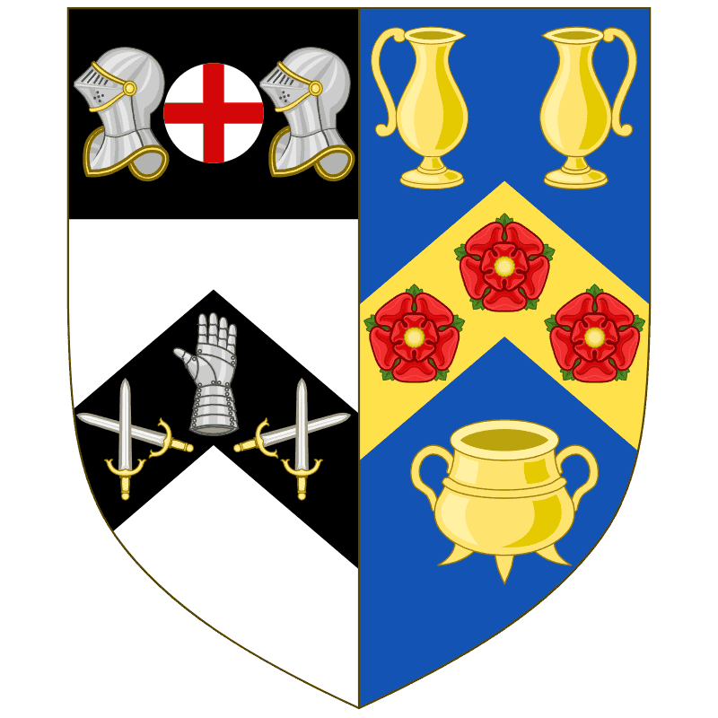
Worshipful Company of: -
Farmers | Basket makers | Brewers | Carpenters | Saddlers
Cutlers (knife, sword and utensil makers) | Armourers and Brasiers | Fishmongers (fish and seafood merchants) | Girdlers (belt and girdle makers) | Grocers (spice merchants)
Information Technologists | Ironmongers | Leather sellers | Mercers (general merchants) | Musicians
Painter-Stainers | Pewterers (pewter and metal manufacturers) | Scientific Instrument Makers | Skinners (skins and furs) | Tin Plate Workers alias Wire Workers
One theory of the idiom “Sent to Coventry”, is that Liverymen expelled from a London Guild went to Coventry, a “free-town”, where Guilds had no influence.

